-1-
Graphic 45 MARCH PLACE IN TIME 2-page layout
Page 1
1. From 12x12 green cardstock:
-Cut out 1 piece at 6 ¼”” x 8 3/8”. Mount 2 photos on it.
-Cut another piece 6 ¼” x 4 ¼”. Mount 1 photo on it.

2. From 12x12 March CutAparts sheet, turn over onto back side, and trim apart the 3 sections
and the border piece. Trim out pieces as shown here:

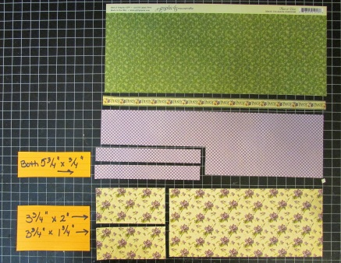
3. From 12x12 purple cardstock: The big piece trimmed out (shown below) is going to be for
Page 2 in this layout, but trim it out (6 ¼” x 8 ½”) now and set it aside. Then, from the top of
the sheet, punch out 2 borders as shown here:

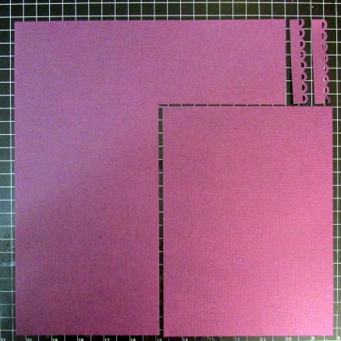
4. Take the 2 floral pattern pieces trimmed out from Step 2, and the 2 border strips from Step
3, and assemble them as shown:

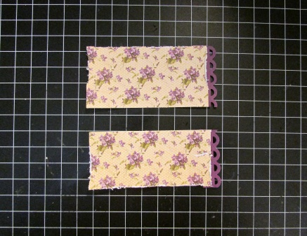
-2-
5. -From the green floral pattern section already trimmed in Step 2, cut pieces from it as shown.
HOWEVER, be careful and look on the front of it, to NOT cut apart the pieces that you’ll need
in Step 2 on Page 6 (these pieces are needed for the card, etc) .
-Then trim more borders from the purple sheet, and attach them to the green floral pieces:

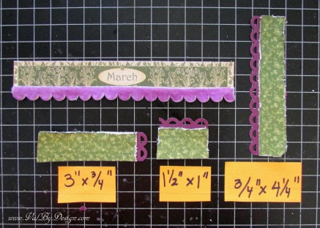
Notice above, that the March section has a piece of the purple scalloped ribbon attached.
6. Assemble the pieces as shown
-(the 2 long purple pieces on the sides are from Step 2)
-(the top & bottom floral pieces are the pieces from Step 4):

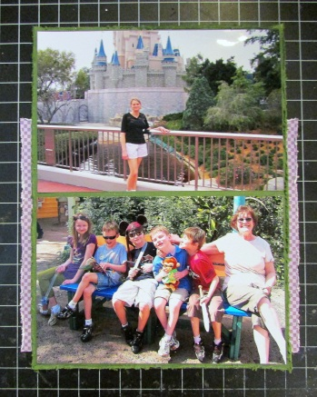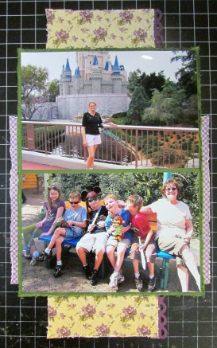

7. Take 2nd March Cut-Aparts sheet and separate all the pieces on the front of the sheet.
8. Assemble pieces on main sheet as shown:
Add square piece with 2 birds/nest: Add 2 scalloped pieces, & assembled March border:
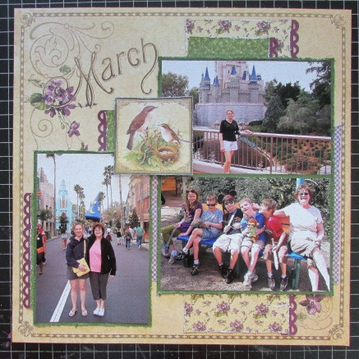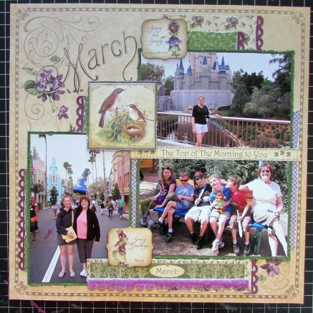

-3-
Add flowers, and bling:
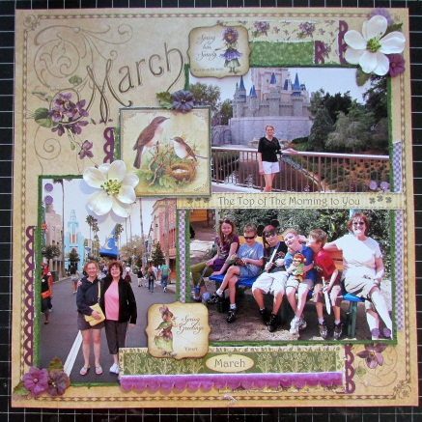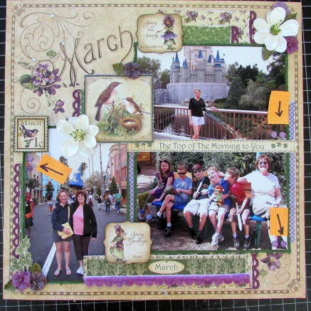

Final page 1 layout:
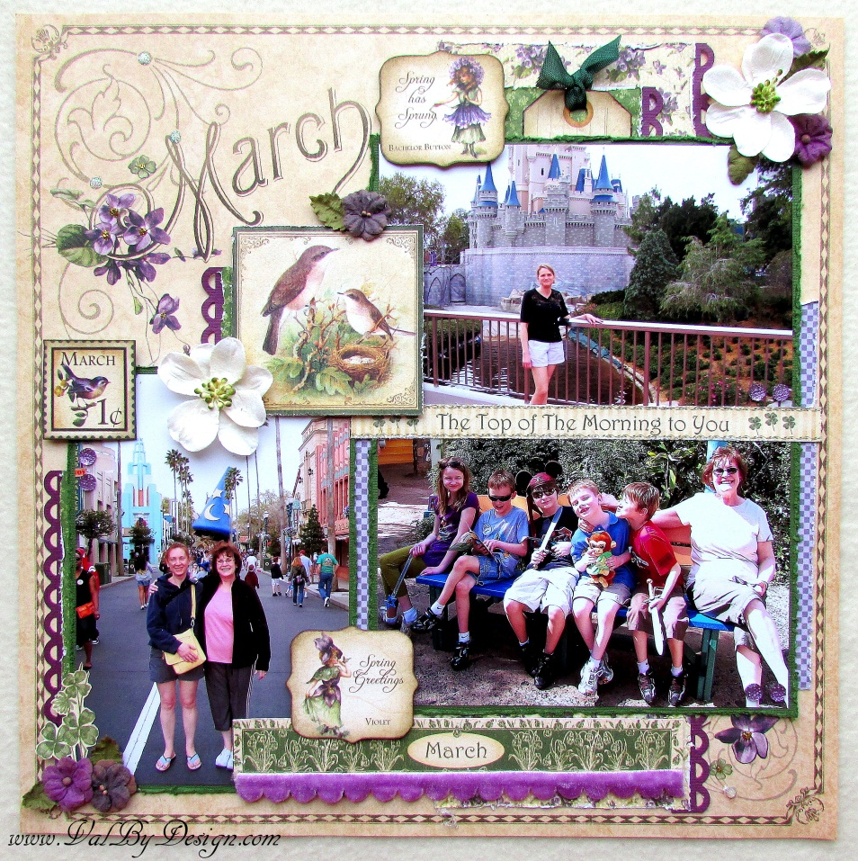

-4-
Page 2

1. From instructions for 1st Page layout, take the purple piece trimmed in Step 3, and mount
your 2 photos on it:

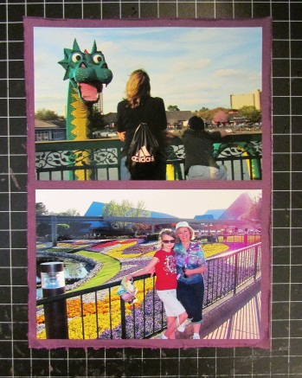

2. Trim apart the pieces from the 2nd sheet of March Cut-Aparts.

3. Take the flowing pieces:
-The left-over purple flower pattern piece from 1st Page layout, Step 2
-The green flower pattern on the back of the stamps images (with a purple border strip
attached)

-The purple flower pattern from 1st Page layout, Step 2

Assemble as shown:
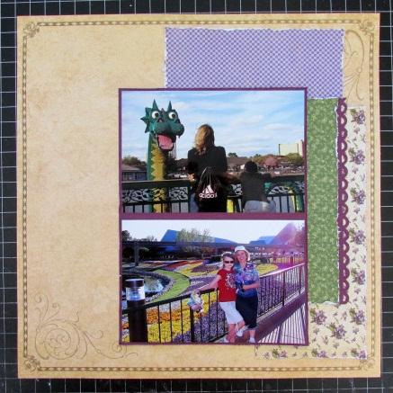

Attach Postcard, & green image piece with purple trim attached:
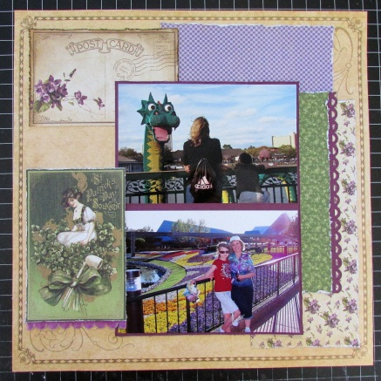
-5-

Attach border pieces on top, March Tag on right, and Stamp in upper middle:
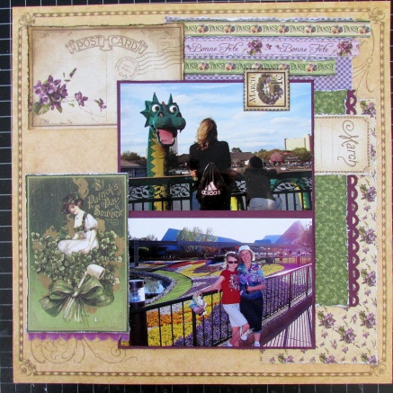

Add 2 Tags with green ribbon, stamp on middle left, scalloped image,
green clovers, “For each petal on the shamrock” phrase, and bird:
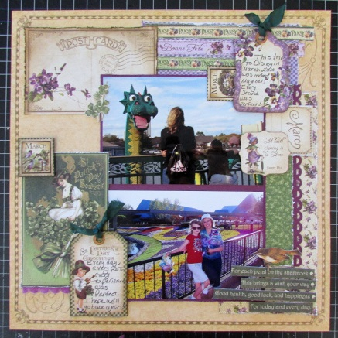

Attach flowers:
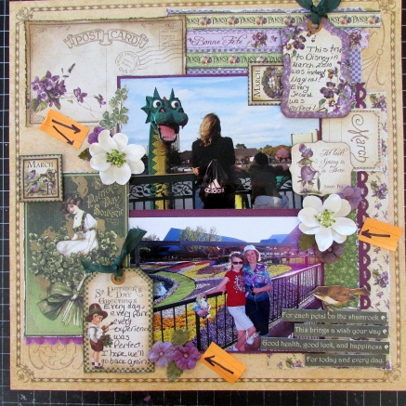

Add bling:
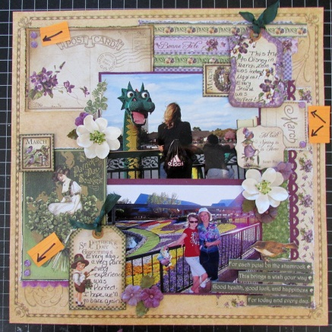
-6-

Final page 2 layout:
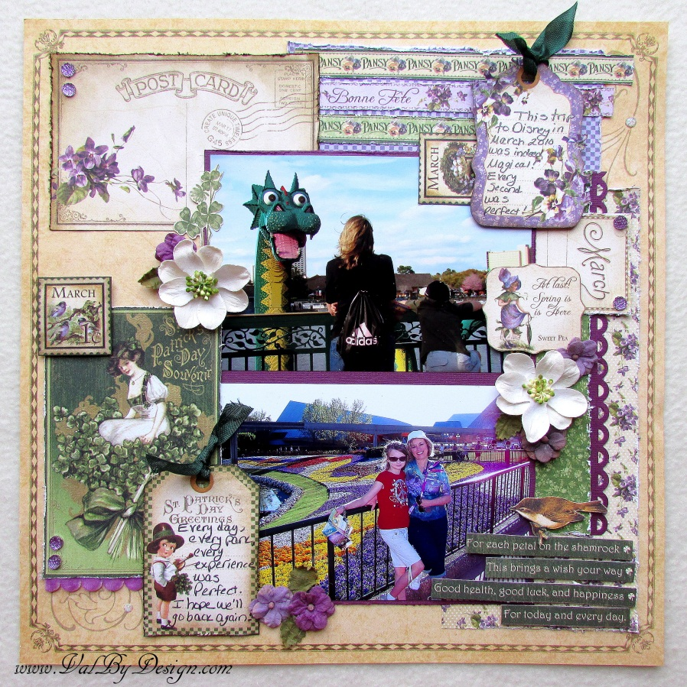
Card:

1. Trim a 4 ¼” x 5 ½” piece from the remaining purple cardstock sheet to fit on your card front:
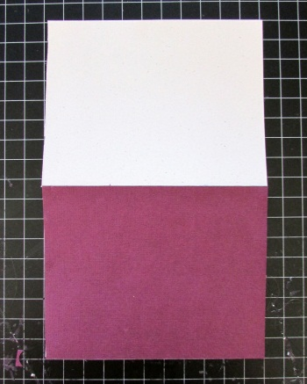

2. These are the remaining pieces left from the pages; you’ll be using some of the images from
the front sides, and some of the patterns from the back sides:
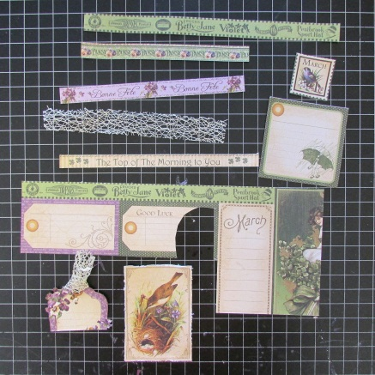

-7-

3. Attach these 2 pieces to the card front:
-The purple flower pattern from the back of the tag with the little girl and the umbrella
-The green floral pattern trimmed from the biggest piece shown in Step 2, shown above
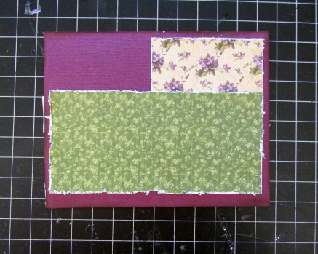

4. -Take the pice of cream colored web-like trim, and trim it in half, length-wise
-Attch them to the 2 pieces as shown:
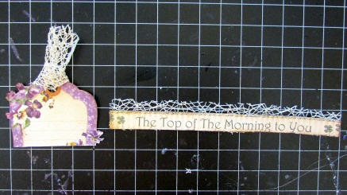

5. Attach a piece of purple velvet scalloped ribbon:
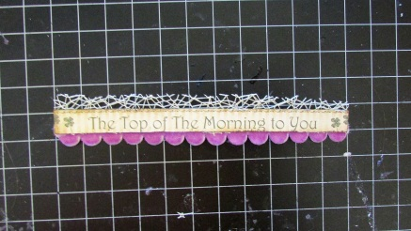

6. Assemble remaining pieces onto card:

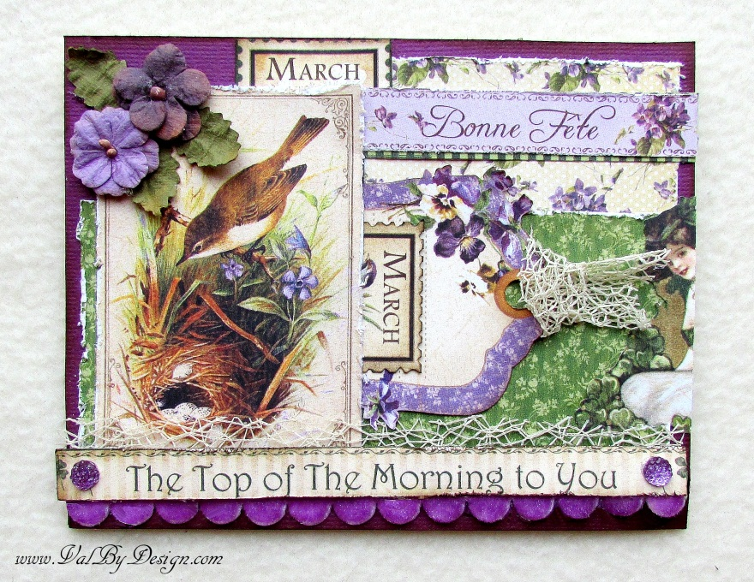
SUPPLIES

(2) March Foundation sheets

(2) March Cut-Aparts sheets

(1) Dark Green 12x12 cardstock

(1) Purple 12x12 cardstock

Petaloo Mulberry New Camelia flowers - White

Floral Darjeeling Petite flowers– Teastaine

Twinkle Goosebumps Purple bling

Ribbon – Purple Velvet scalloped ½ yard (18”)

Ribbon – Cream “web” 1/3 yard (12”)

Ribbon – Green 1/3 yard (12”)

1 A2 card & envelope

