-1-
First Page of Graphic 45 NUTCRACKER SWEET 2-page layout
1, With Festive Fairytale cardstock, trim 2 borders, Candy Cane & Green, off, keeping them intact. Keep the leftover center section of the page together.
2. With Christmas March cardstock (on the back with the red & cream swirls), trim the outside perimeter off to mount on the back of the first border piece from Step 1.
3. Assemble the 2 borders together – Step 1 border on top of Step 2 border.
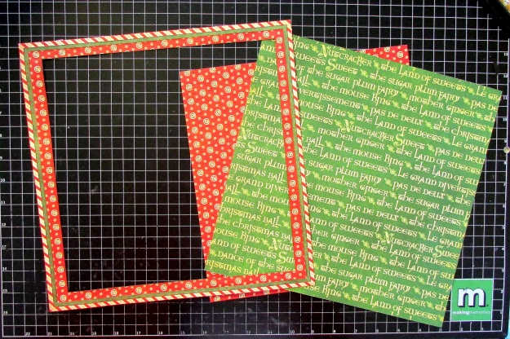
4. Mount assembled borders on top of Bazzil Purple/Dots cardstock, and mark where to cut out the center so you leave a thin border on the inside. Trim the center out.
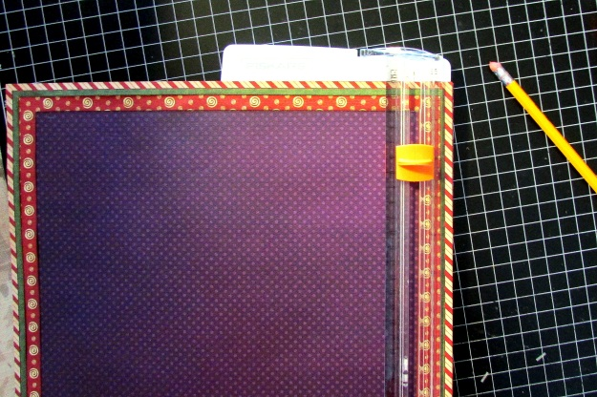
5. Mount purple border underneath assembled border from Step 3.
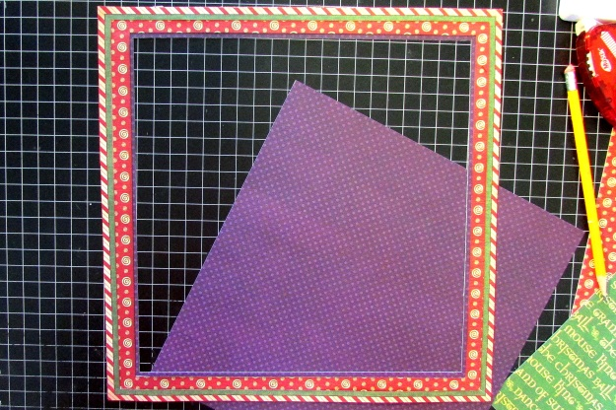

-2-
6. With Endearing Sentiments cardstock, punch (4) 12” strips with border punch. Trim the corners at a 45 degree angle so they fit together nicely.
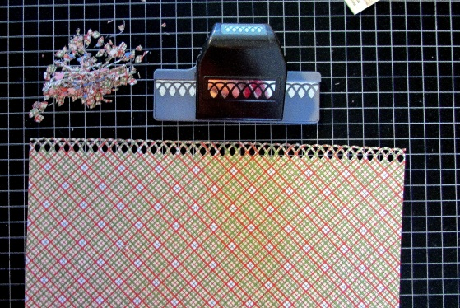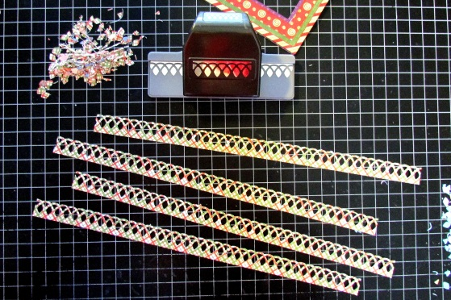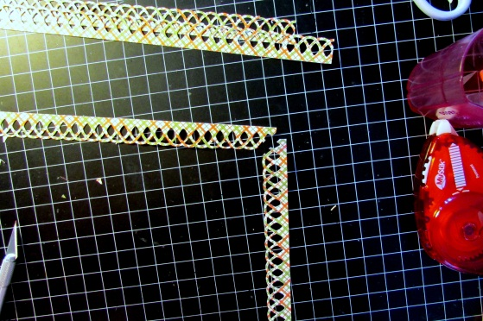
Attach them to the back of the assembled borders:
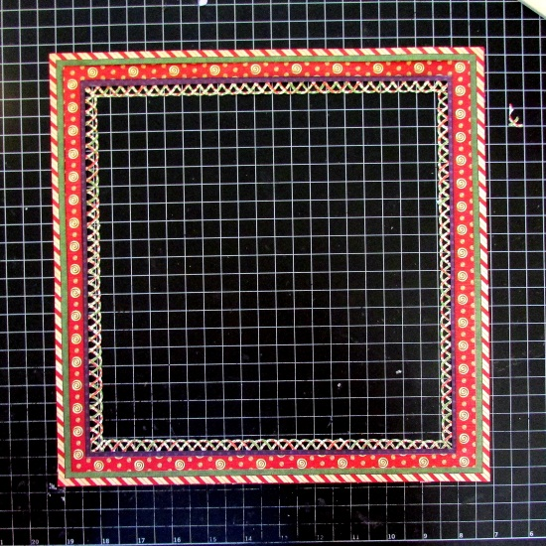
7. With Red cardstock, trim a perimeter border to mount behind the assembled borders, and ON TO the Enchanted Journey sheet, NOT on to the back of the assembled borders like all the others. You’ll see why in the next step!
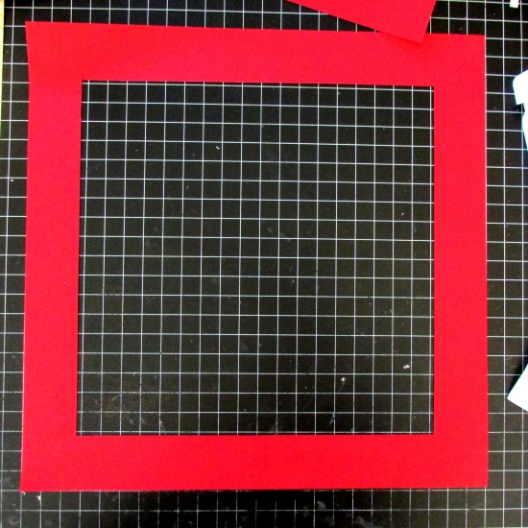
(Keep the left-over red square that’s been cut out for Step 9 on the Second Page layout)

-3-
8. Put pop dots on the back of the assembled borders, and adhere on to the main cardstock sheet (Enchanted Journey and red cardstock that have been adhered together). 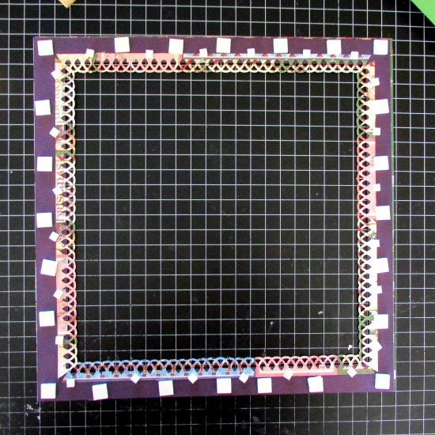 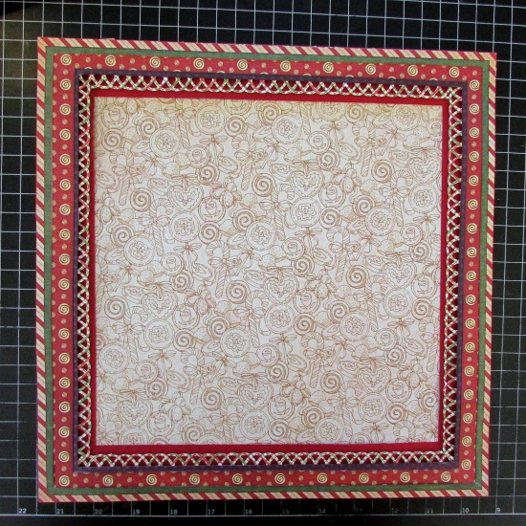 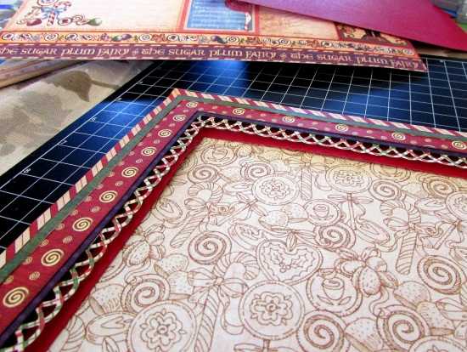
9. Trim 7 Nutcrackers out from the bottom of the Christmas March cardstock. [and you’ll need 5 more for the second page of the layout, too ;) ]
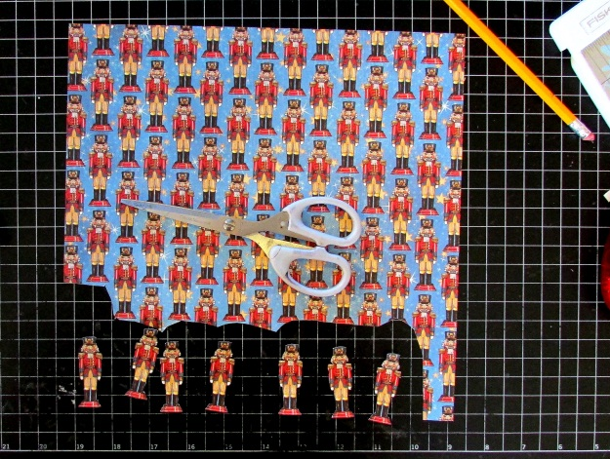
10. Trim all the borders you’ll need:
- Purple Sugar Plum Fairy border from Endearing Sentiments sheet
- Green Land of Sweet border from Endearing Sentiments sheet
- Candy & Roses border from Endearing Sentiments sheet
- Purple/Green Nutcracker Sweet border from Festive Fairytale sheet

The rest is cutting & adding embellishments!
Now, on to Page 2 of the layout…

-4-
Second Page of Graphic 45 NUTCRACKER SWEET 2-page layout
1. Trim 3/8” off one vertical side, and 3/8” off one horizontal side of green cardstock. Then trim out the center of it, leaving a 1 ½” border.

Center it and mount it onto the red cardstock.
2. Trim ½” off one vertical side, and ½” off of Enchanted Journey cardstock. Center it and mount it onto green cardstock (which was mounted on to red in Step 1).
3. Pull out the leftover Bazzill Purple & Dots cardstock from Step 4 on the First Page layout (will be approximately 10” x 10”). Rotate it 45 degrees so it looks like a diamond on your table. Trim off one corner, about 1 ¼” of it:

Trim off about 1 ¼”

-5-
Now, lay that piece of paper [the maim piece (not the small trimmed off piece)] on to your main layout, and mark where to trim off the other corner. Trim off the other corner.
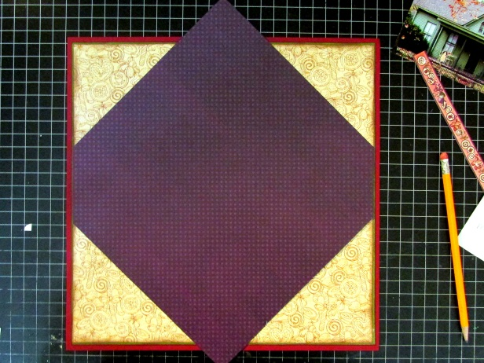
4. Trim the purple cardstock again, as shown:
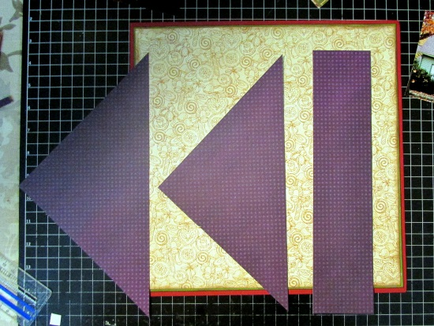
-5-
5. Cut the center strip from the purple cardstock into 2 strips to use as borders.
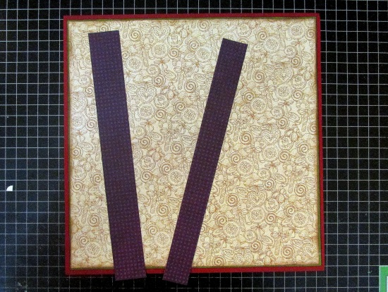

-6-
6. Take your 2 photos and mount them side by side, and adhere the 2 purple strips from Step 6 onto the top and bottom of the 2 photos.
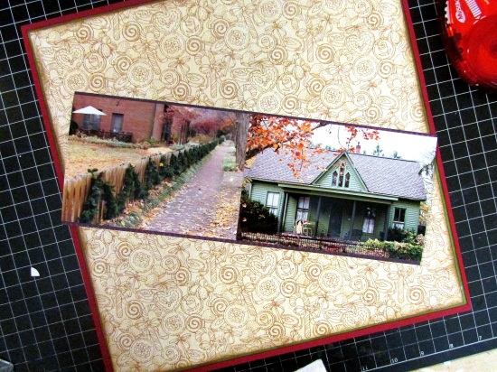
7. With Endearing Sentiments sheet, trim this into pieces needed, such as:
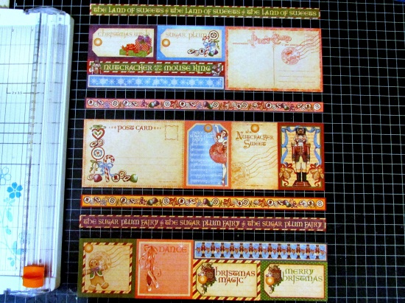
Take the center piece and punch the border punch on both sides, and cut in half length-wise:
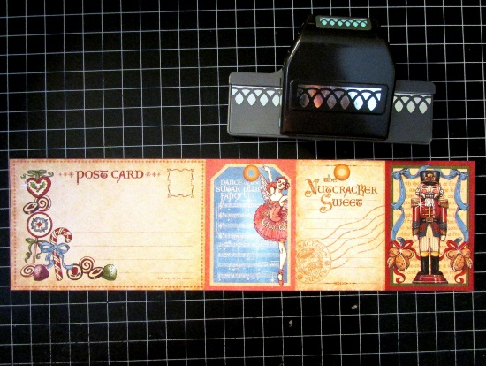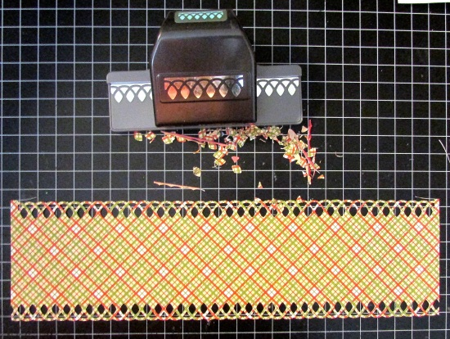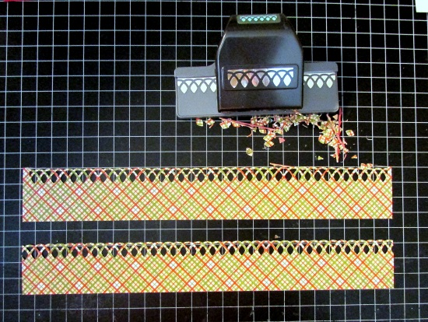

-7-
8. Mount the borders from Step 7 on to back of 2 assembled photos/purple borders from Step 6
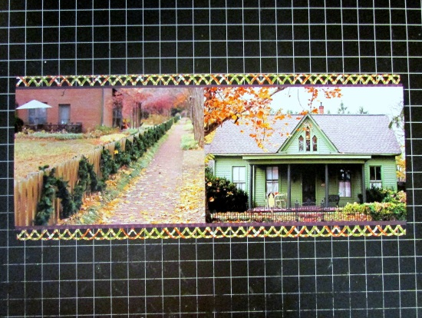
9. Now, to the main layout of this whole second page!:
Take the left-over red square from Step 7 on the First page Layout. Center it, and adhere it to the main layout.
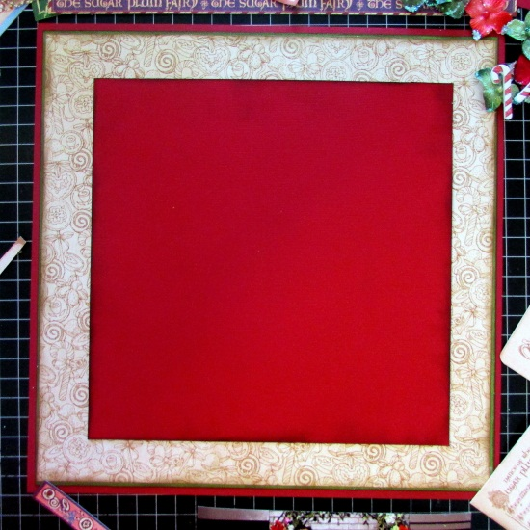
10. Punch a border with the border punch, and adhere it, along with all the other embellishments and the 2-photo spread on to the page
