-1-
Graphic 45 FEBRUARY PLACE IN TIME 2-page layout
1. With one piece of 12x12 black cardstock, cut out 3 pieces at 4 1/8” x 6 1/8”, and 1 piece at 5 1/8 x 7 1/8”. Then, mount the 4 pictures on the black pieces.
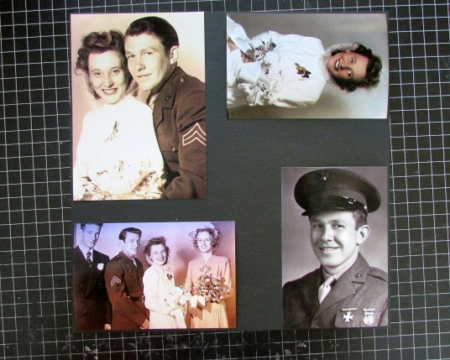
2. Take the 2 sheets of February Cut-Aparts and separate all the different pieces of the cut-aparts side, and on the other page separate the 3 different patterned sections.
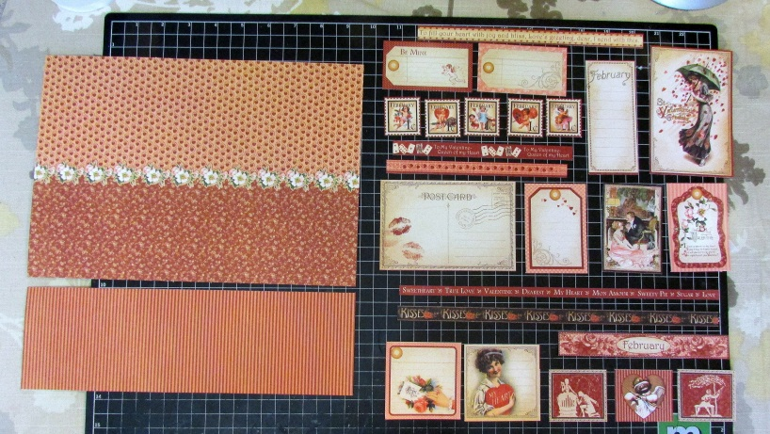
3. (this step is not necessary, and the tools & supplies will not be included in Hannah’s kit):
-At this point, I like to distress all the pieces from the cut-aparts side with my Edge Distresser.
-Then I ink the edges with my ink applicator and Ranger Distress Ink (Walnut Stain).
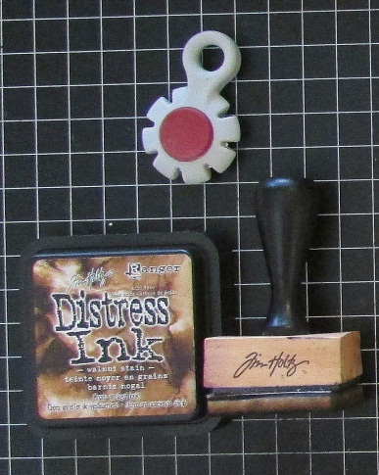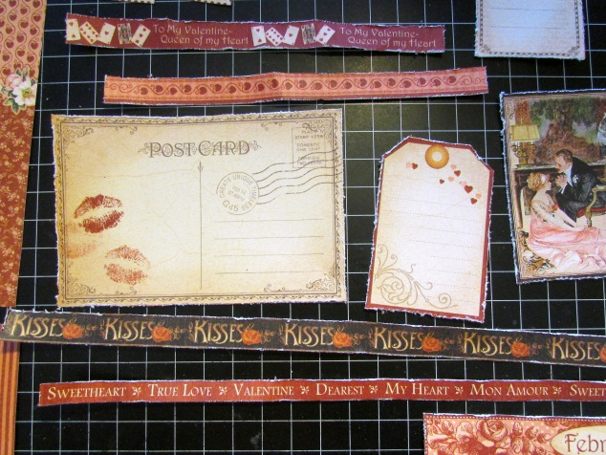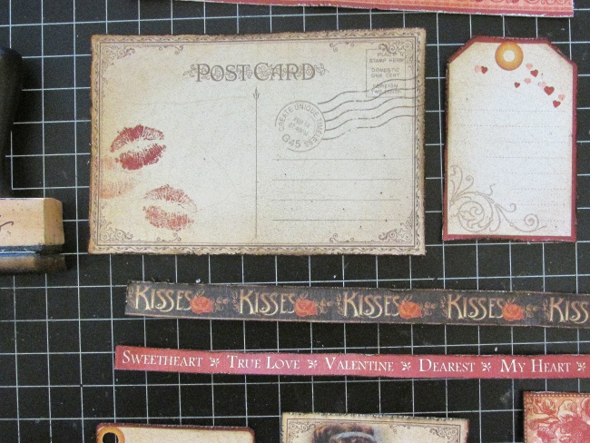
These are a Must in First they’re distressed… …then they’re inked
my scrapbooking!
-2-
4. Trim the tags, punch holes in the tops. Thread the brown ribbon through. Now all your pieces from that sheet are ready.
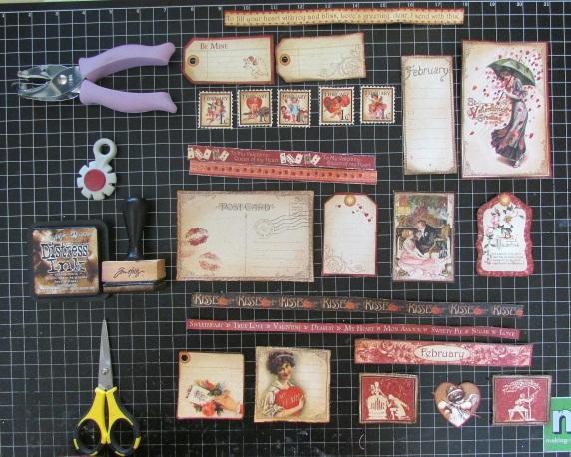

5. Now get the pieces from the 2nd sheet of Cut-Aparts that you trimmed apart. You need to carefully trim out around the edges of the flora strip. Then you’re going to eventually cut it apart into pieces similar to this, to us behind your images on the sheets.
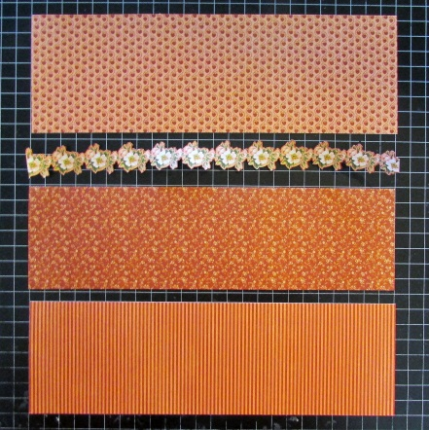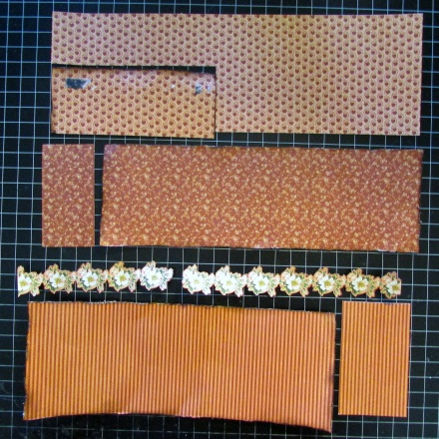

6. Find the pieces you’ll be attaching ribbon to, and glue them onto the backs of the pieces (I like to use Glossy Accents).
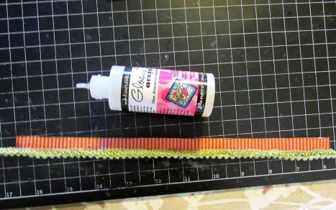

7. Apply Distress Stickles on any of the pieces you’d like to have a dry, clear, crackled finish to. I applied it to all the flower images, the February 1-cent stamp images, and the 2 cut-aparts that have a red background with a white image. IMPORTANT: LET IT DRY! It takes about an hour.
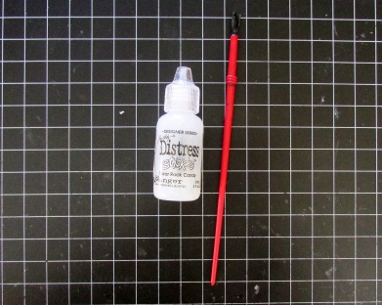 After all the pieces and images are dry (and crackled!), assemble!

February Place in Time Supply List

(2) G45 Place in Time – February Foundation .99 ea = 1.98

(2) G45 Place in Time – February Cu9-Aparts .99 ea = 1.98

(1) 12x12 black cardstock .59

12” (1/3 yard) brown ribbon (from tag) (2 yards = $2) .33

24” (2/3 yard) green tassel ribbon (1 yard = $1) .67

12” (1/3 yard) cream May Arts ribbon (1 yard = $1) .33

(1) Distress Stickles – Clear Rock Candy 2.50

$ 8.05

