-1-
Graphic 45 DECEMBER PLACE IN TIME 2-page layout
1. With one piece of 12x12 cream cardstock, cut out 4 pieces at 4 3/16” x 6 3/16”.
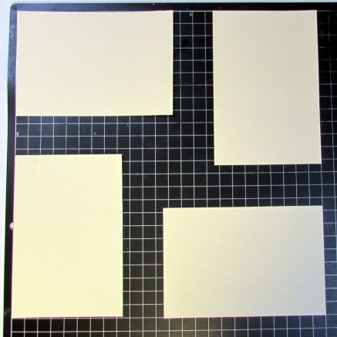
2. With one piece of 12x12 black cardstock cut out 4 pieces at 4 5/16” x 6 5/16”.

3. Mount black pieces on cream, and mount 4x6 photos on the very top.
4. -With 2 pieces of December Cut-Aparts cardstock, trim from each piece the green floral
pattern rom the backs (keep them in the original size and shape they are on the cardstock).

-With Land of Sweet cardstock from the Nutcracker collection, trim 2 pieces at
3 ¾” x 12”.

-With another piece of 12x12 black cardstock, punch one border with ek Success chain
border punch, and cut it in half lengthwise.
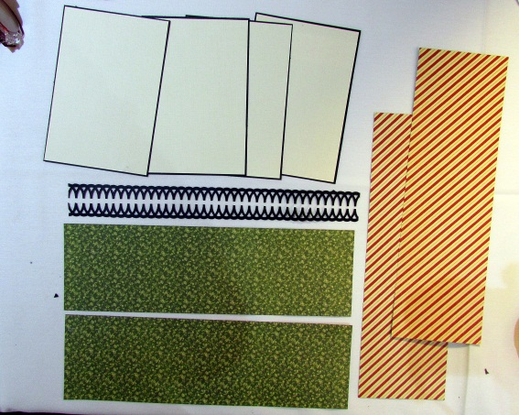
-2-
5. Assemble as shown:
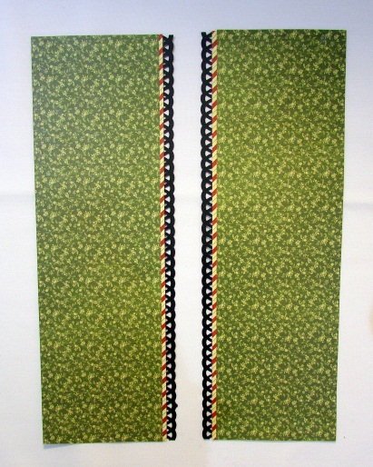
Attach them to the 2 base cardstocks (December Foundation)

6. Take one remaining piece of December Cut-Aparts, and trim 3 different sections into pieces:
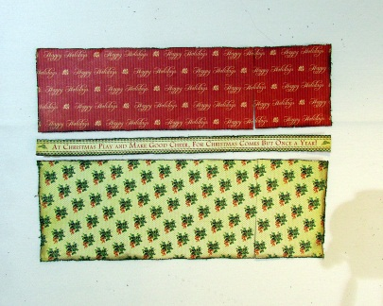

7. -Attach green tassel ribbon onto top and bottom of the red Happy Holidays portion.

-Trim 12” of white lace ribbon, and cut in half length-wise.
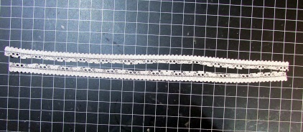
Attach it to the top and bottom of cream w/mistletoe pattern.

8. Lay the assembled pattern cardstock and ribbons on top of 2 base cardstocks (December Foundation), and slice the assembled sections (not the base cardstock!) where they get separated with the 2 sheets of base cardstock:
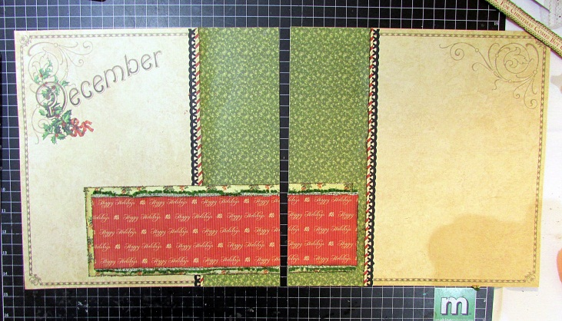
-3-
9. Take 2nd remaining piece of December Cut-Aparts and cut all the pieces apart:
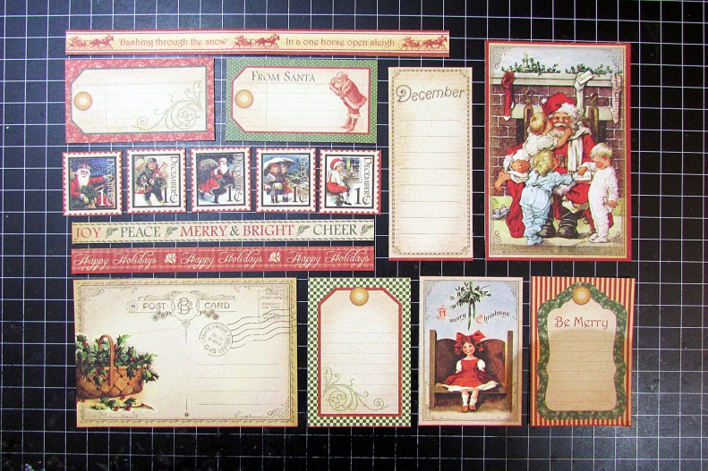

10. Add red felt ribbon to tags
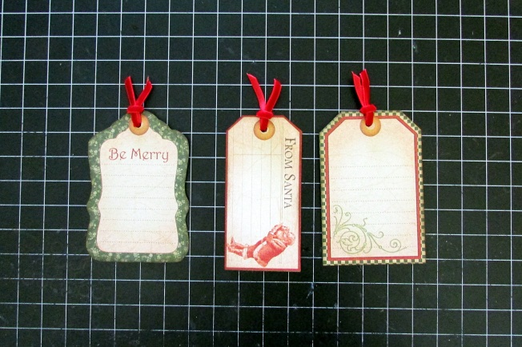
11. Add white lace ribbon to 2 photos (the one on the first page, and the top one on the right page)
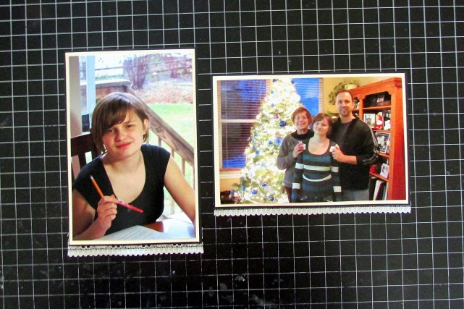

12: Assemble everything

13. The final touch, add Red Christmas Stickles to red berries images on 1st page. Be very careful and let it dry; it takes at least an hour.
